DATABASE ASSIGNMENT
Grade: Worth 4% of your overall grade
Final Due Date: FEBRUARY 28, 2026 (evening by 11:59pm)

The purpose of this assignment is to ensure that everyone acquires the skills necessary to process data from a database. Since queries are logic-intensive, focus on how to solve the problems rather than worrying about the SQL commands. Please begin working on the assignment promptly and avoid waiting until the due date.

Important Notes

Although extreme care has been taken to be precise with the instructions and questions, inadvertent errors may appear. Any reported errors will be promptly notified to everyone. The material covered in class is sufficient to answer all of the questions.

For submissions: 1) in one document, please attach the SQL code (only the code, not the output) used to answer each question along with the answer for each question; 2) in a separate document, please attach the code used to answer each question along with the output. You can screenshot your sql query code and the output (only first few rows if there are a large number of rows). For example, see below:
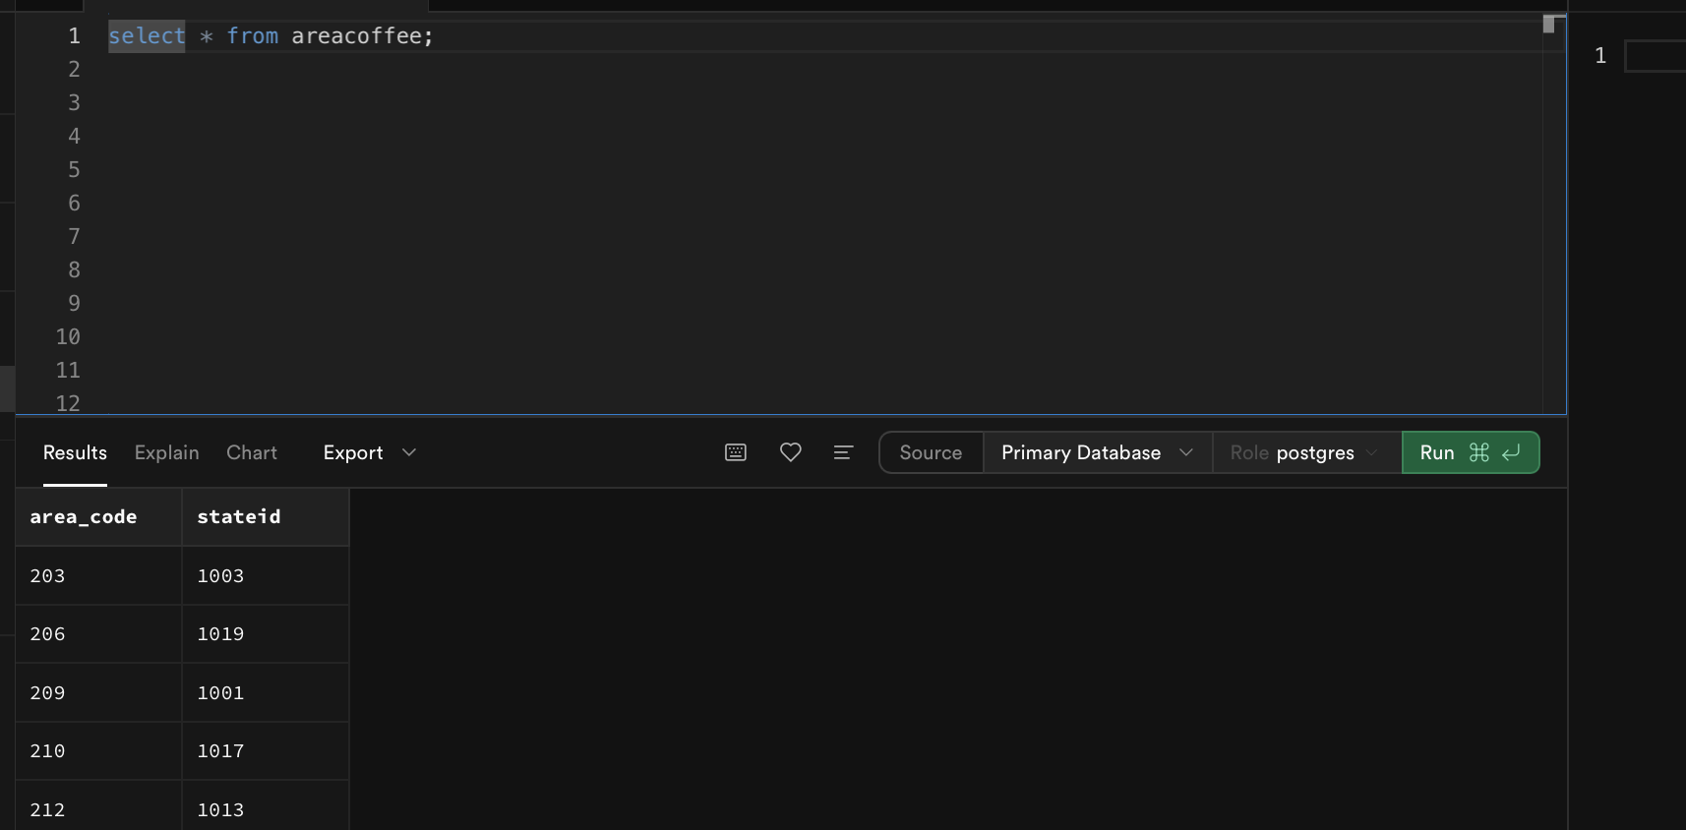
If you are using multiple queries to answer a question, label different parts appropriately. In your answer, also explain how different queries are combined to arrive at the main results for that question. Please include this explanation in the first file before each query.

Failure to submit the assignment in this format will result in points lost. Sql Code should be consistent in both the files.

Part 1: Coffee Store Data (20 points – 5 points for each Item)
Brew and Leaf Company sells different coffee and tea products. They organize their data in different tables as explained in the class. You are required to analyze this data to understand their business performance.
Please run queries on the data and answer the following questions. If not specified, decide the appropriate attributes to display.

- BUDGETED Numbers:
Budgeted numbers represent planned figures. A business typically has budgeted figures for metrics such as COGS (cost of goods sold), sales, margins, profits, etc. You aim to analyze how your stores performed compared to the budgeted values using the following queries:
- The budgeted numbers serve as expected targets. Calculate difference in profits and budgeted profits for states for the year 2019. Arrange the states in the descending order of this difference in profits and identify top five states with the highest difference.
Hint: You will need to perform state-level calculations, which require associating transactions with their respective states and then aggregating the information by state. Use limit clause to get the top five.
- Calculate difference in margin and budget margin for products for the year 2019. Arrange the products in the descending order of this difference in margins.

- MARKETING EXPENSES AND PROFITS:

Write queries to analyze the marketing expenses and answer the following questions:
(Note: You don’t have to breakdown the expenses by date).
  - Find the top 5 products that have the lowest marketing expenses as a percentage of sales? (Hint: Use the formula sum(marketing expense)/ sum (sales) while grouping by product)
  - Do the above 5 products also have the highest profits as a percentage of sales? (Hint: Use the formula sum(profits)/ sum (sales) while grouping by products and see if any of the top five products match with the top five products in B.1 )

- DECLINING PROFITS:
In a high-level strategy meeting to discuss performance improvement, considerations may include closing stores in area codes with profit declines and/or expanding in areas with high profitability/growth. Analyze the data and recommend which stores to close and where to expand. Explain your rationale and submit it along with your query.
Note: These queries will require a design that includes subqueries. Initially, you will need to write subqueries to assess performance for each time period. Then, utilize these subqueries in the main query to compare performance across different time periods. Alternatively, create separate tables using subqueries and incorporate them into the main query. Include all relevant SQL code in your write-up, following the instructions provided at the outset.

Part 2: Porfolio Data (10 points)
Investo manages asset portfolio for different clients. The data is stored in four tables described below.

-- Investors Table
Investors (
InvestorID INT PRIMARY KEY,
Name VARCHAR(100),
Email VARCHAR(100) UNIQUE,
RiskTolerance VARCHAR(100)
)

-- Portfolios Table
Portfolios (
PortfolioID INT PRIMARY KEY,
InvestorID INT,
PortfolioName VARCHAR(100),
CreatedDate DATE
);

-- Assets Table (Stocks, Bonds, etc.)
Assets (
AssetID INT PRIMARY KEY,
Symbol VARCHAR(10) UNIQUE,
AssetType VARCHAR(100),
CurrentPrice DECIMAL(10,2)
);

-- Transactions Table
Transactions (
TransactionID INT PRIMARY KEY,
PortfolioID INT,
AssetID INT,
TransactionType VARCHAR(100),
Quantity INT,
PricePerUnit DECIMAL(10,2),
TransactionDate DATE
);

Use script db_investment.txt to create these tables and insert data. Examine this data

Please run queries on the data and answer the following questions. If not specified, decide the appropriate attributes to display.

  - Determine the most frequently traded asset across all portfolios (4 points)

  - Write a query to calculate the total value portfolio based on the latest asset prices (6 points)
Hint: Consider only those transactions where the type is “Buy”. Use the quantity from transactions and currentprice from assets to determine the value of each asset. Aggregate this value across all assets for each portfolio.

. Part 3: Search Engine Marketing (10 points)

You are analyzing paid search advertising performance for a firm that sells products in two categories: Footwear & Supplements. Each keyword ad appears in different ad positions across months.

Remember:
- Higher position → higher CTR and higher CPC
- Sales quantity = 0.1% of impressions
- Revenue = sales_quantity × price
- Spend = impressions × ctr × cpc
- Profit = revenue − spend

Database Setup

The file sem_data.txt provides the SQL scripts needed to:
- Create the necessary tables
- Insert all keyword data
- Insert all marketing performance data

Run the script in PostgreSQL before starting the exercise.

Table Definitions

The dataset contains two tables:

TABLE keywords (

keyword TEXT PRIMARY KEY,

product TEXT NOT NULL);

TABLE marketing_performance (
keyword TEXT NOT NULL REFERENCES keywords(keyword),
month DATE NOT NULL,
position INT NOT NULL,
impressions INT NOT NULL,
ctr NUMERIC(6,5) NOT NULL,
cpc NUMERIC(6,2) NOT NULL,
sales_quantity INT NOT NULL,
price NUMERIC(8,2) NOT NULL,
PRIMARY KEY (keyword, month));

• position – ad rank (1 = highest visibility)
• impressions – number of times the ad appeared
• ctr – click-through rate
• cpc – cost per click
• sales_quantity – units sold (0.1% of impressions)
• price – selling price per unit

Scenario 1 — Growth Strategy (Footwear)
Business Context
Management wants to invest more aggressively in Footwear advertising — but only for keywords that are clearly profitable.
They want to:
- Identify which keywords generate the most total profit
- Determine whether higher positions actually increase profit

Write an SQL query to answer the following questions:
Questions
- Which 3 Footwear keywords generate the highest total profit?
- For each keyword, which position generates the highest profit?
- Should the firm bid for Position 1 for all keywords? Why or why not?

Scenario 2 — Cost Reduction Strategy (Supplements)
Business Context
Advertising costs are rising. Management wants to reduce spending in Supplements by identifying underperforming keywords.
They want to:
- Identify keywords losing money
- Determine which keywords should be downgraded or paused

Write an SQL query to answer the following questions:

Questions
- Which keywords have negative profit?
- Which of these generate relatively low revenue?
- If you had to cut 2–3 keywords, which would you choose? Explain your reasoning.

